What is the difference between a while & a do-while loop.

Draw flowcharts for both of them. What is the minimum no. of times the body of the loop in each case will be executed?

The main difference between while and do while is that while loop check condition before iteration of the loop and on the other hand do while loop verifies the condition after the execution of the statements inside the loop.

For eg

Int no=10;

While ( no < 10)

{

}

In this as the condition is not satisfied it will not enter the while loop.

In do while even if the condition does not satisfies .it will enter the loop and then if the condition does not satisfies it will not enter again

Eg

Int no=10;

do

{  
System.out.println(“hello”);

}while(no < 10);

Here it will enter do and hello is printed on the console

Its flowchart

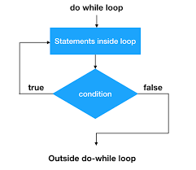

Flowchart for while loop

